**Developing coordination, exercise tolerance, stamina and fitness**

*Handle is optional on all exercises* but may be useful for providing support to adult when assisting in certain exercises.*

*\* (Except for grade 3 exercises where handle should be removed)*

[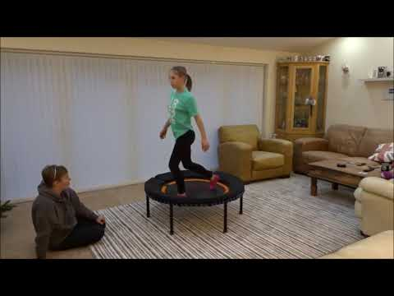](https://www.youtube.com/watch?v=6tw7e37KhME)

If the link in the video thumbnail above does not play the video on your device, please use this web page to view:   
<https://www.youtube.com/watch?v=6tw7e37KhME>

Grade 1, Exercise 8: Enjoys being bounced in sitting position

Grade 1, Exercise 9: Sitting position - initiates movement by pushing into bed with hands

Grade 1, Exercise.10: Sitting position - swimming arm movement to initiate bounce

Grade 1, Exercise 13: High kneeling position

Grade 1, Exercise 14: High kneeling - swimming arms to initiate movement

Grade 1, Exercise 17: Standing position - initiate bounce (bobble)

Grade 1, Exercise 18: Standing position - swimming arms to initiate movement

Grade 1, Exercise 19: Standing position - hang and bounce

Grade 1, Exercise 20: Standing position - pogo in centre

Grade 1, Exercise 21: Standing position - bounce and stop - stillness

Grade 2, Exercise 4: Sitting position - push hands, bounce and half time tweak

Grade 2, Exercise 5: Sitting position - bounce and half time tweak, swimming arms

Grade 2, Exercise 6: Quarter turns in sitting position

Grade 2, Exercise 7: Can achieve two footed jump - landing evenly

Grade 2, Exercise 8: Can achieve two footed jumps repeatedly - landing evenly

Grade 2, Exercise 9: Perform 3 bounces - stop - stillness

Grade 2, Exercise 10: Standing position - bounce with quarter twists

Grade 2, Exercise 11: Standing position - bounce with quarter twists, performs left and right

Grade 2, Exercise 12: Haka (fast knees up and touch)

Grade 2, Exercise 15: Jump to legs astride - bring arms up, jump to legs together, bring arms down. (Jumping Jack)

Grade 2, Exercise 16: Jumping Jacks continuously)

Grade 2, Exercise 17: Run on centre of bed

Grade 2, Exercise 18: Run on centre of bed - knee slapping

Grade 2, Exercise 24: Half kneeling - swimming arms to stand to stillness

Grade 2, Exercise 25: As G2, Ex.24 - able to perform right and left knee up

Grade 2, Exercise 26: Back bouncing

**ALL GRADE 3 EXERCISES - HANDLE TO BE REMOVED**

Grade 3, Exercise 1: Jumping with arm movements

Grade 3, Exercise 2: Tuck jump